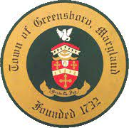
Kevin Reichart, Mayor
Tammy Kelledes, Town Manager

PO Box 340
Greensboro, MD 21639
410-482-6222

Greensboro Parks and Recreation Commission
3.9.2022 Agenda

- Call to order

- Approval of January 12, 2022 meeting minutes

- Discussion

  - Ober Park
  - Upcoming events

- Adjournment

Upcoming dates
3.17.22 Town Council Workshop
4.7.22 Town Council Meeting

