November 19th 2019

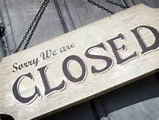

Town Hall will be closing @
2pm
on 11/19/19 for an
employee meeting.

